Math 3130 Take Home 4 Name________________________

6-25-18

Read each problem carefully and show all of your work.

3) Find the general solution (and the solution to the IVP if applicable) for the following forced harmonic oscillators.



4) Match the equation with the appropriate graph. Explain you reasons.



1 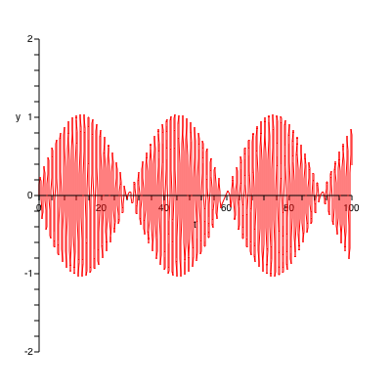 2 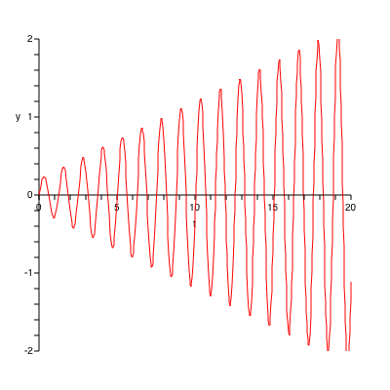 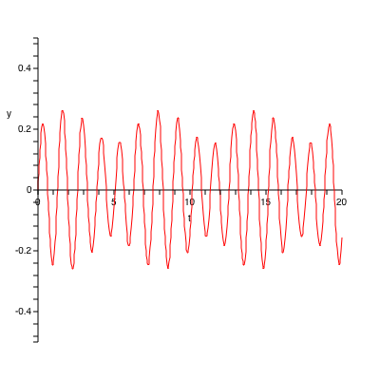 4